Script to show all created tables:

select * from user_tables;

Script to show all created views:

select * from user_views;

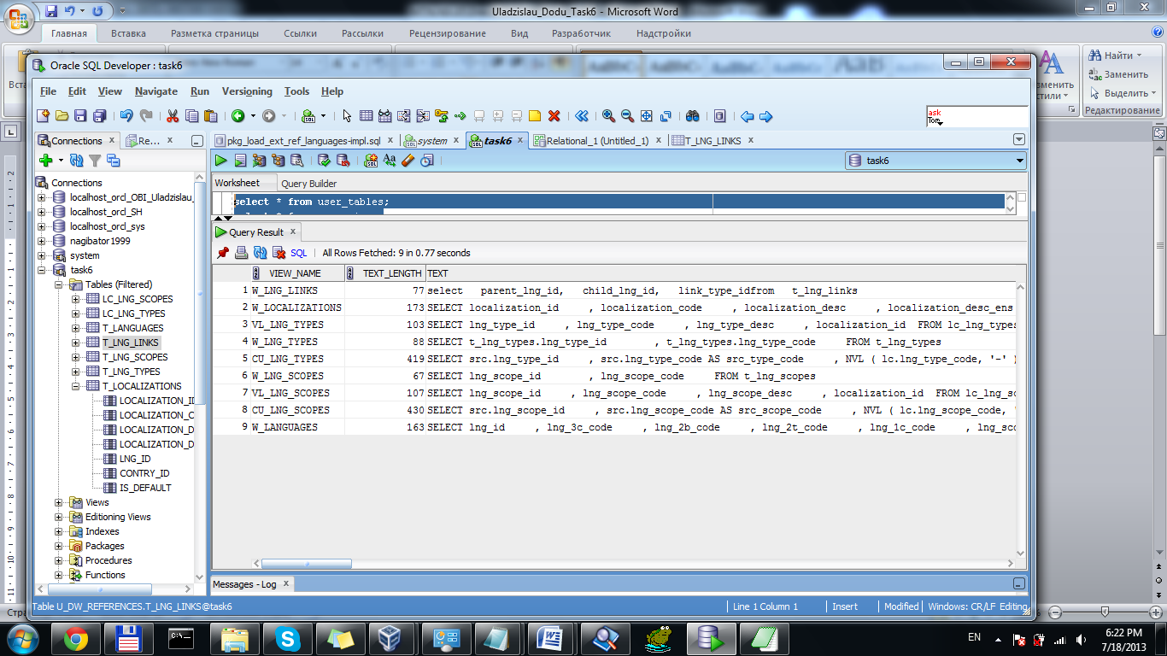

Capture 1 – All created views

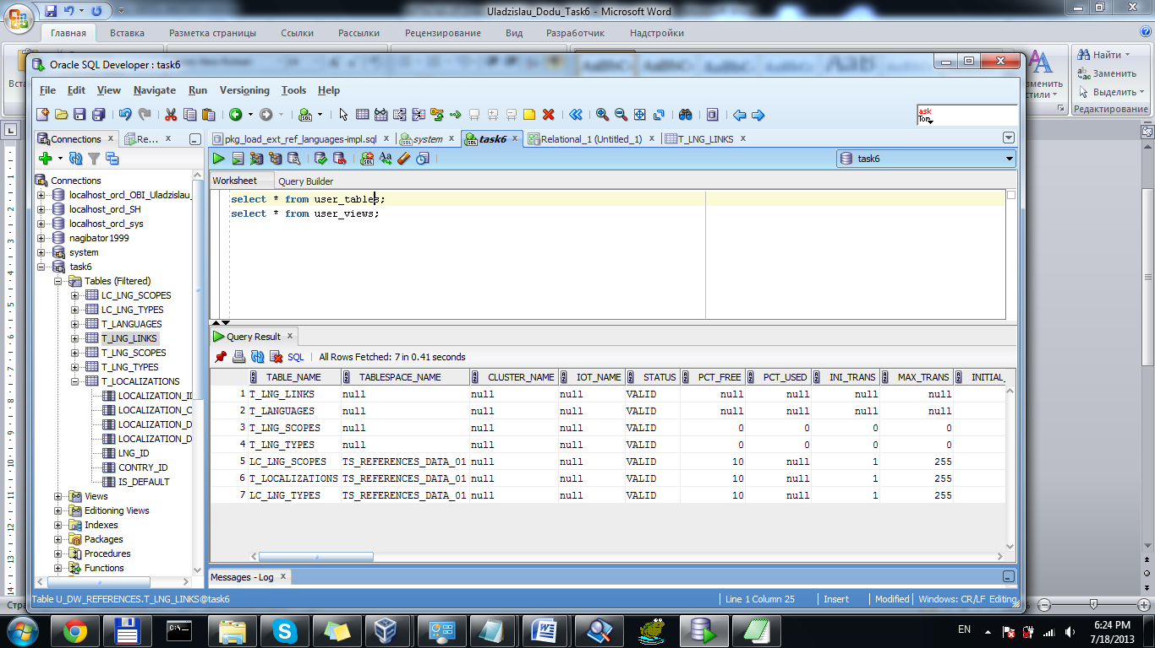

Capture 2 – All created tables

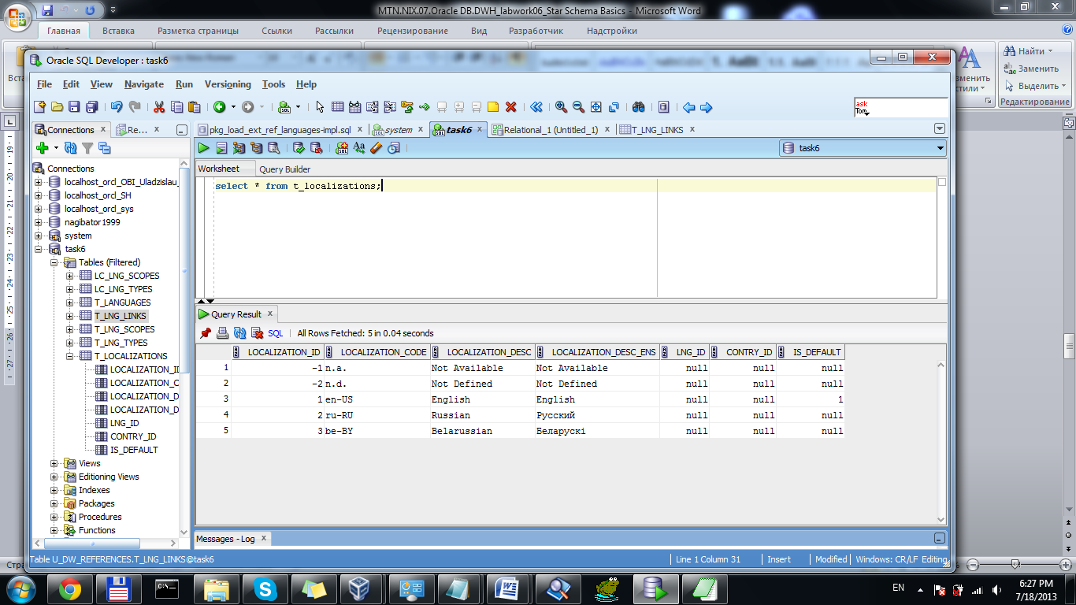

Capture 3 – Localization table’s data

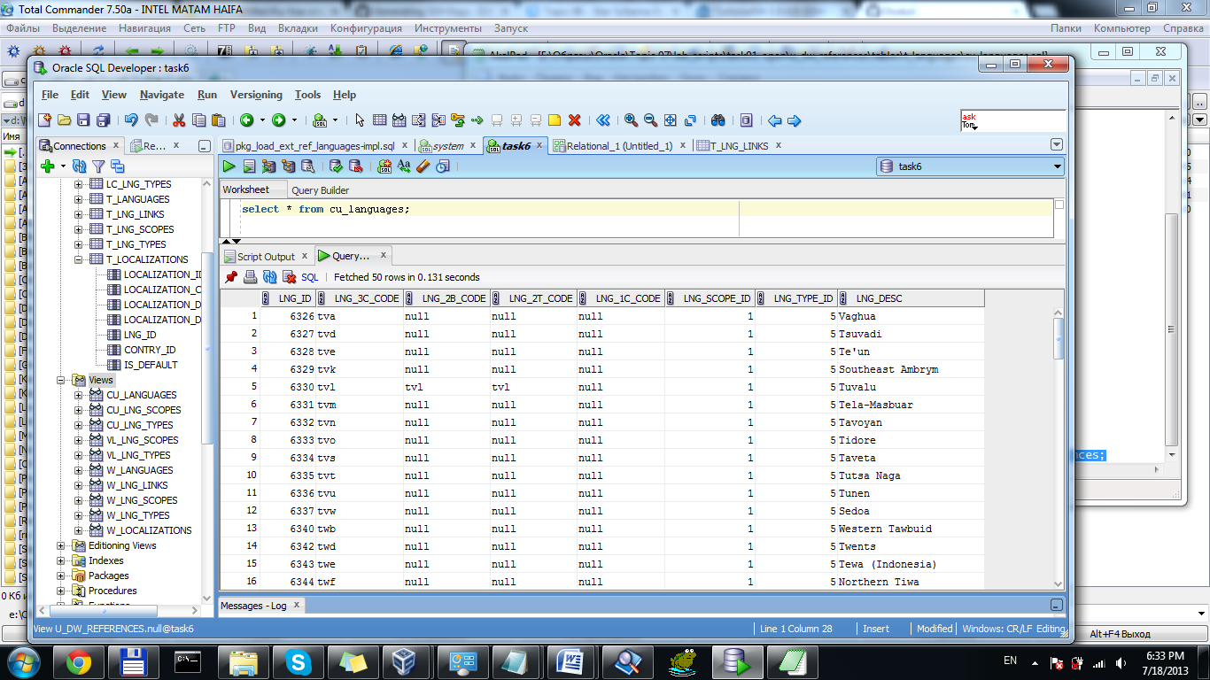

Capture 4 – CU_Languages

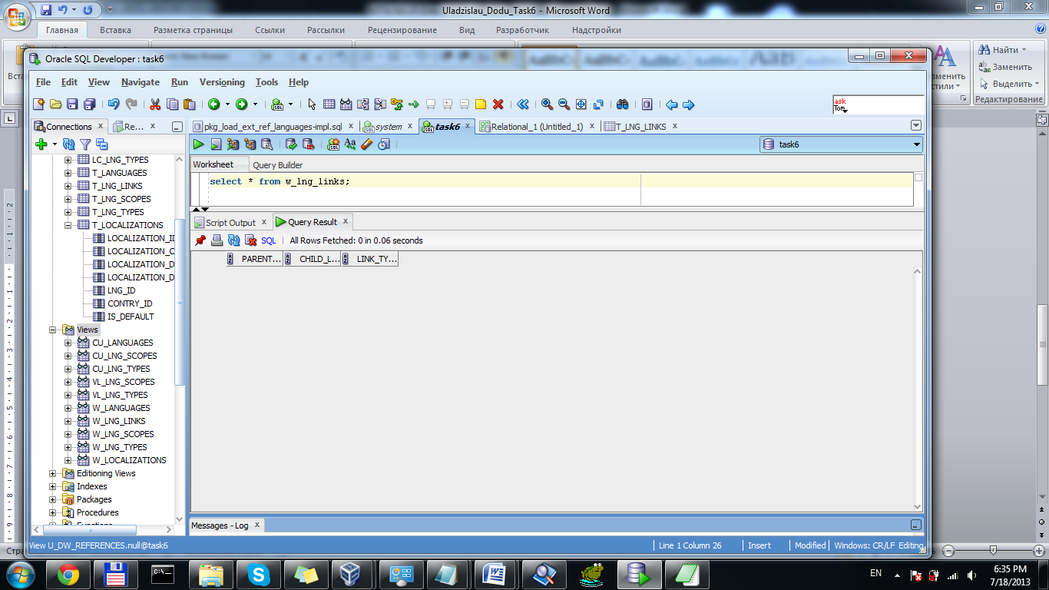

Capture 5 – W_LNG_LINKS

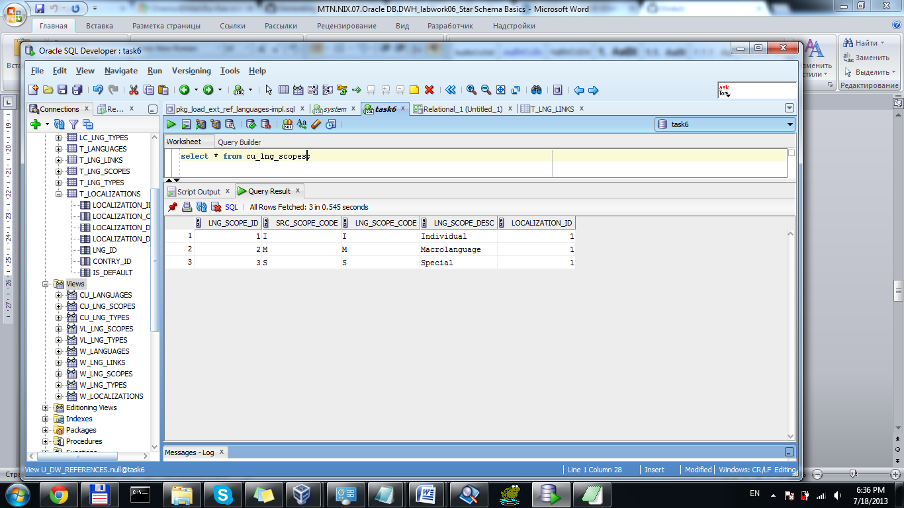

Capture 6 – CU_LNG_SCOPES

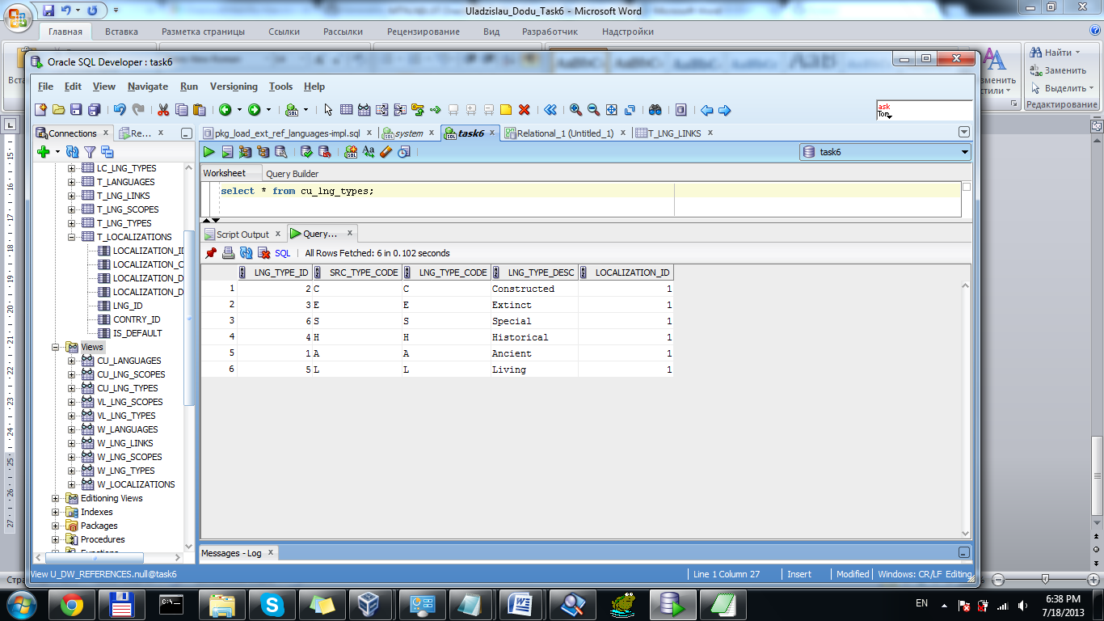

Capture 7 – CU_LNG_TYPES

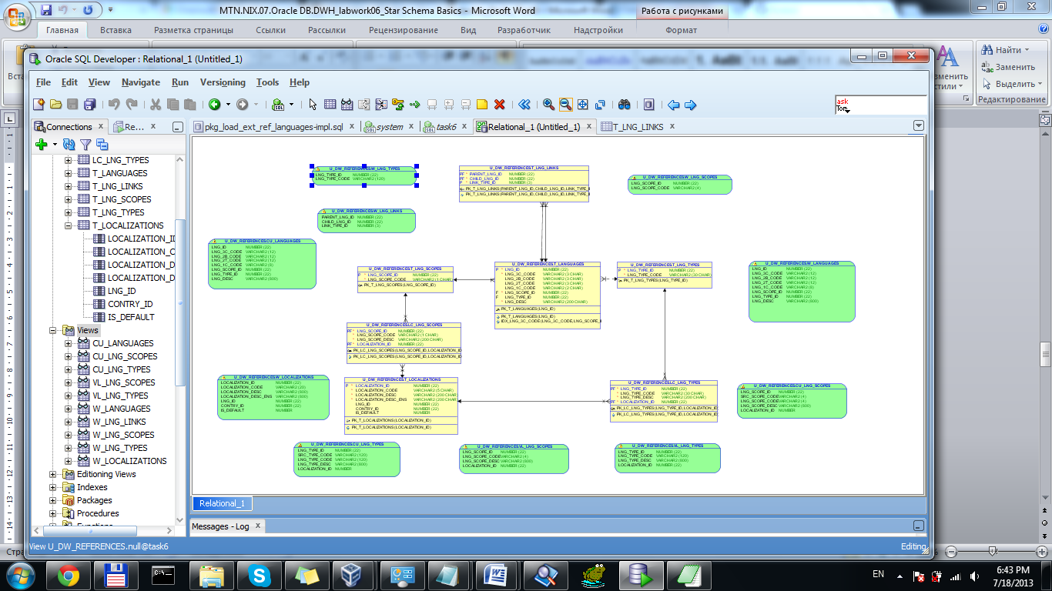

Capture 8 – ERD

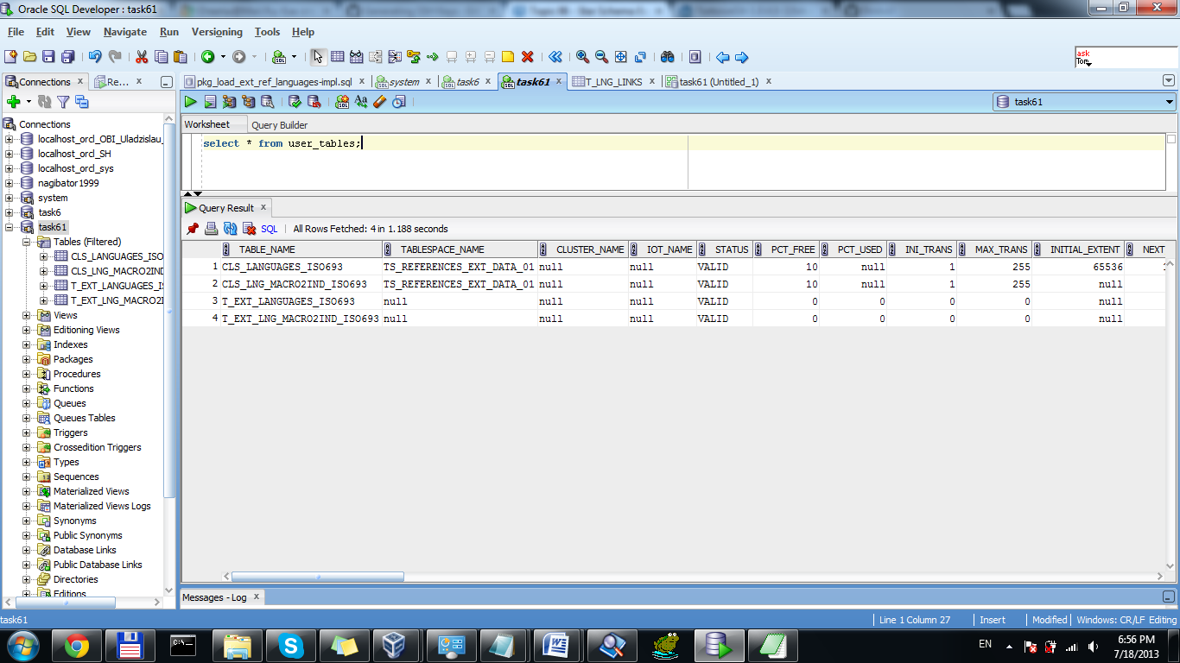

Capture 9 – Ext_references user’s tables

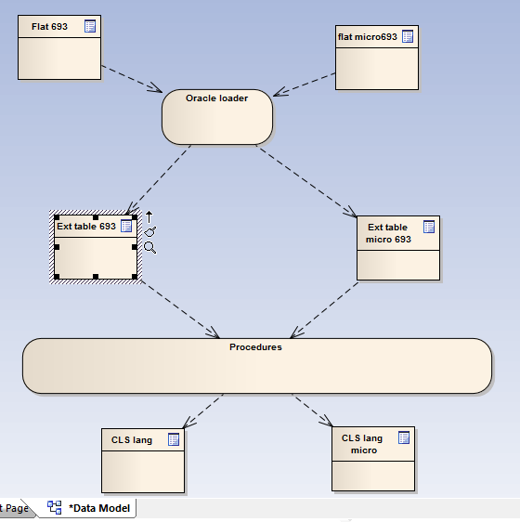

Capture 10 – Data flow sketch diagram

Task 2

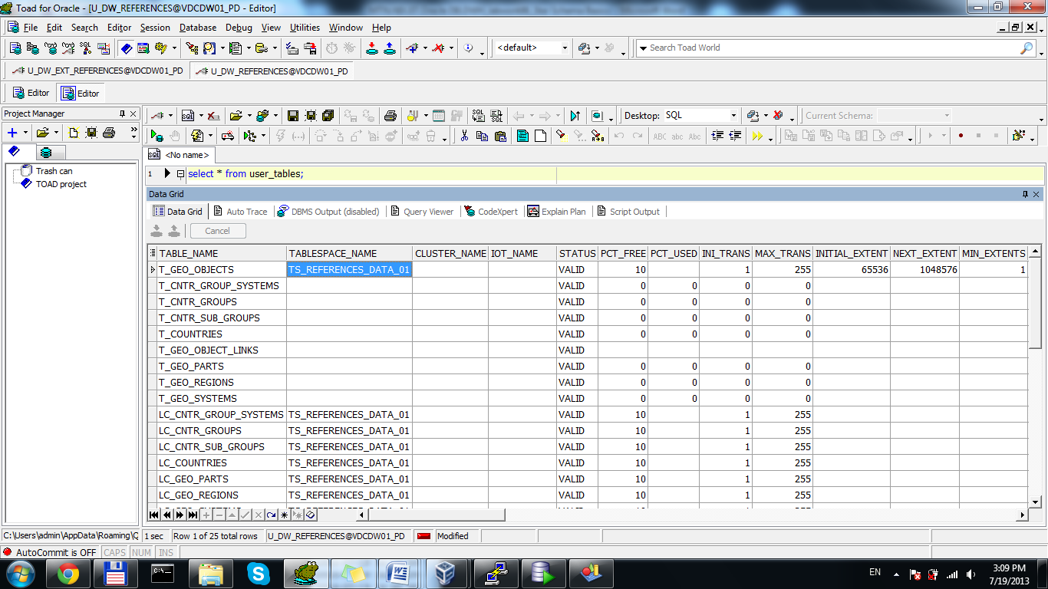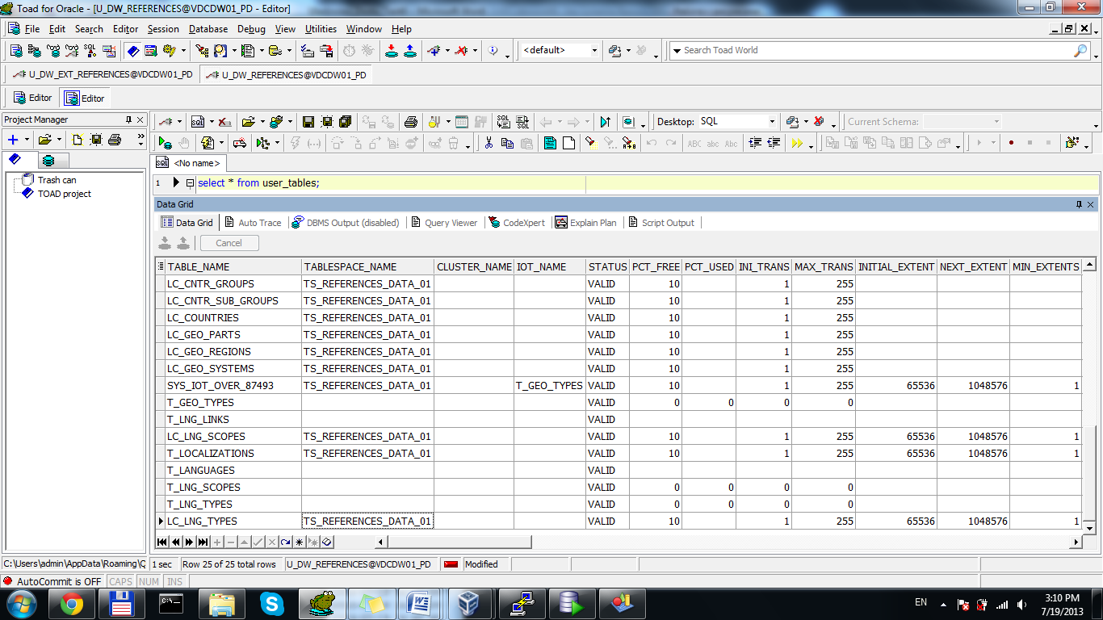

Capture 11 – All created tables

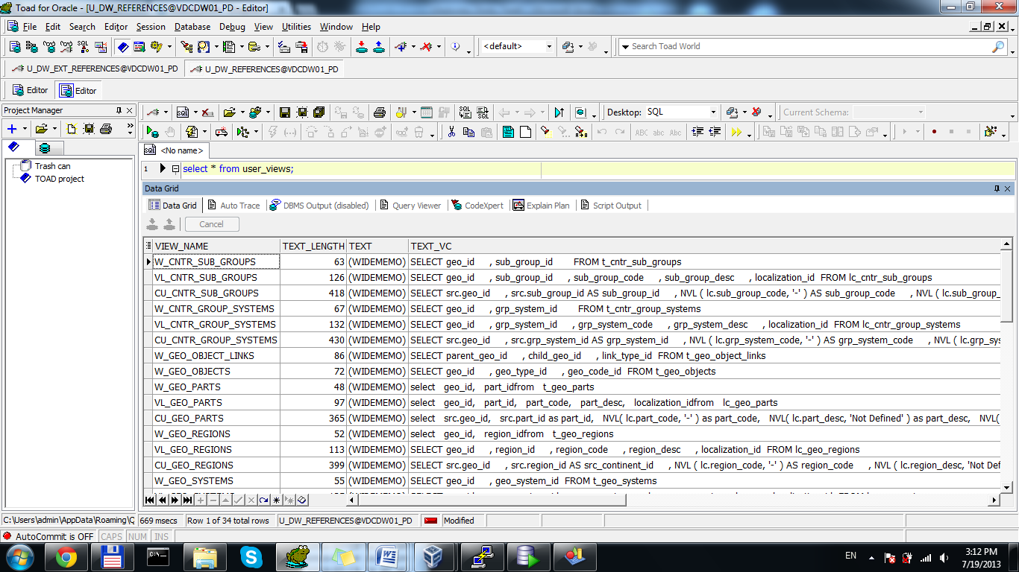 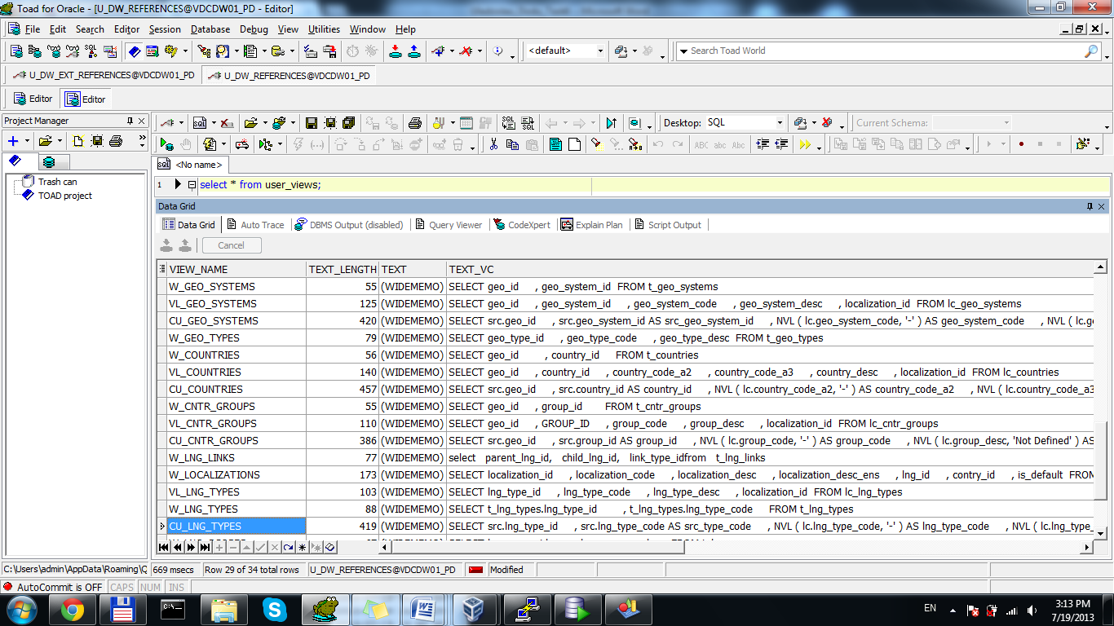 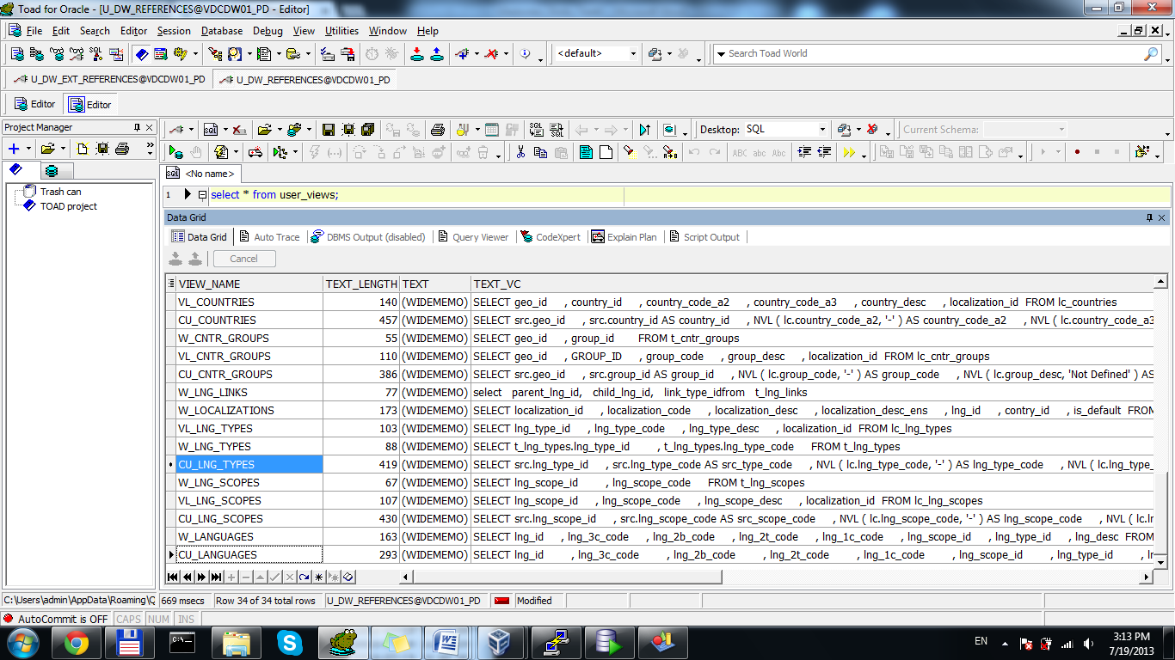

Capture 12 – All Created views

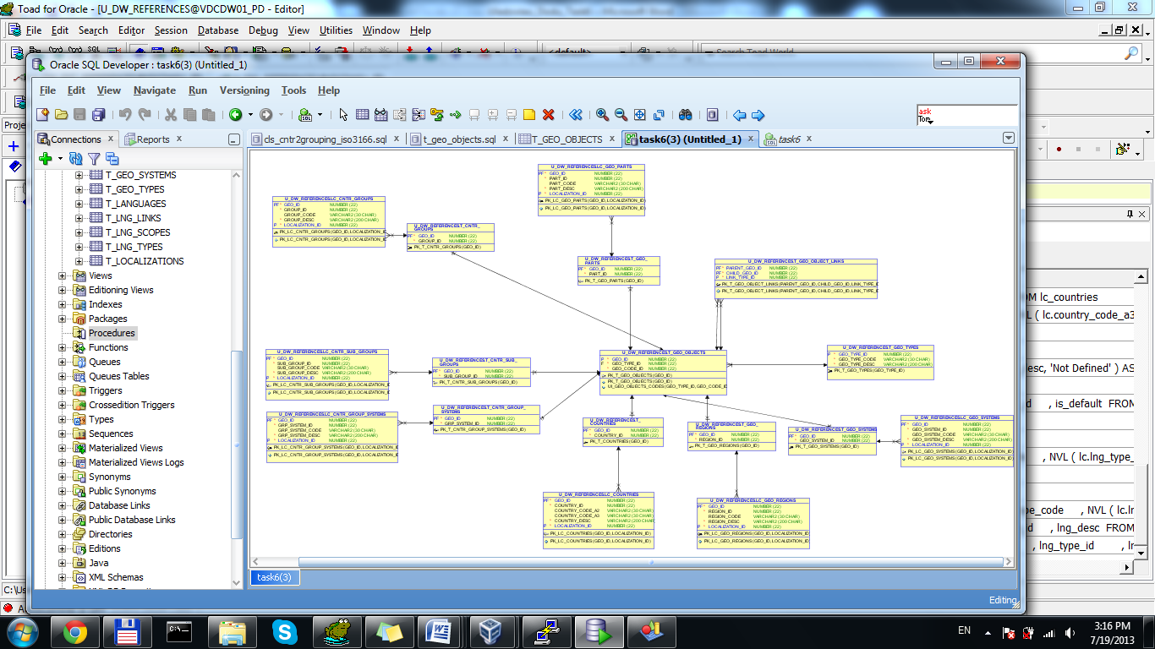

Capture 13 – Physical diagram of T_Contries

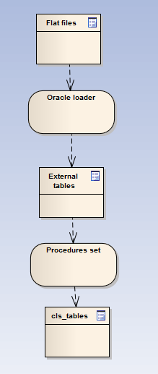

Capture 14 – Flow Data